Heading in template for full paper (<120 characters, incl. space)
N.N. Surname
Company, City, Country
N.N. Surname
Company, City, Country
N.N. Surname
Company, City, Country
N.N. Surname
Company, City, Country
N. Surname
Company, City, Country

ABSTRACT: A summary of the paper shall be presented here and the abstract should be limited to not more than 500 words in English.

GENERAL INSTRUCTIONS

Typefont, typesize and spacing
Use Times New Roman 11 point size and 12 point line spacing (Standard text tag). Use Times New Roman type except for the headings (Heading tags), parameters in mathematics (not for log, sin, cos, ln, max., d (in dx), etc.), titles of journals and books should all be in italics. Never use bold except to denote vectors in mathematics. Never underline any text. Use the small font (10 points on 11 points) for tables (Table Text style tag), figure captions (Caption style tag) and the references (Reference text tag). Never use letterspacing and never use more than one space after each other.

Third Level Heading

GETTING STARTED

Title, author and affiliation frame
Type the title of the paper in lower case (no caps except for proper names). The title should not be longer than 120 characters including spaces).
Type the name of the first author (first the initials and then the last name). If any of the co- authors have the same affiliation as the first author, add his name after an & (or a comma if more names follow). Type the correct affiliation; Name of the institute, City, State/Province, Country, do not add street names, P.O. Box numbers or zip codes to the affiliations. If there are authors linked to other institutes, place the cursor at the end of the affiliation line just typed and give a return. Now type the name(s) of the author(s) and after a return the affiliation. Repeat this proce- dure until all affiliations have been typed.

Abstract frame
If there are no further authors, place successively the cursor one space after the words AB- STRACT: and type your abstract of not more than 500 words in English. The complete abstracts will fall in the first page, the settings of which should also not be changed (width: Exactly 15.0 cm or 5.91"; height: Automatic; vertical: 7.2 cm or 2.83" from margin; Lock anchor).

First line of text or heading
If your text starts with a heading, replace GENERAL INSTRUCTIONS with the correct text for the heading. Start with the text after a return. This text should have the tag First paragraph.
If your text starts without a heading, you should place the cursor immediately before GEN- ERAL INSTRUCTIONS, change the style tag to First paragraph and type your text after deleting the words GENERAL INSTRUCTIONS, but not the return at the end.

LAYOUT OF TEXT

Text and indenting
The maximum total length of the paper, including first page is 10 pages. All text, figures, tables, etc. should fit exactly in the type area of 15 × 24 cm (5.91" × 9.52"). All text should be typed in Times New Roman. All text is 11 pt on 12 pt line spacing except for the paper title (16 pt on 18 pt), author(s) (12 pt on 13 pt), affiliation(s) (10 pt on 11 pt) and the small text in tables, captions and references (10 pt on 11 pt). All line spacing is exact. Never add a line space between lines or paragraphs.
First lines of paragraphs are indented 4 mm (0.16") except for paragraphs after a heading or a blank line (First paragraph style tag). Equations are indented 12 mm (0.47").

Headings
Type primary headings in capital letters roman (Heading 1 style tag) and secondary and tertiary head ings in lower case italics (Headings 2 and 3 style tag). Headings are set flush against the left margin. The tag will give two blank lines (24 pt) above and one (12 pt) beneath the primary headings, 1½ blank lines (18 pt) above and a ½ blank line (6 pt) beneath the secondary headings and one blank line (12 pt) above the tertiary headings. Headings are not indented and neither are the first lines of text following the heading indented. If a primary heading is directly followed by a secondary heading, only a ½ blank line should be set between the two headings.
In Word, this has to be done manually as follows: place the cursor on the primary heading, select Paragraph in the Format menu, and change the setting for spacing after, from 12 pt to 0 pt. In the same way the setting in the secondary heading for spacing before should be changed from 18 pt to 6 pt.

Listing and numbering
For listing facts, use the Bullet style.
- Example bullet
- Example bullet

Equations
Use the equation editor of the Word program. Equations are indented 12 mm (0.47") from the left margin (Formula tag). Number equations consecutively and place the number with the Tab key at the end of the line, between parentheses. Refer to equations by these numbers. See for example Equation 1 below:

From the above, we note that sin θ = (x + y)z or
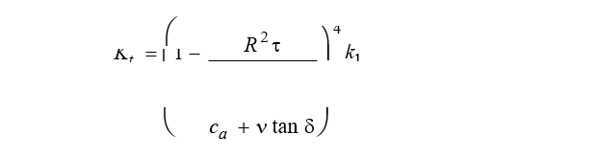
where ca = interface adhesion; δ = friction angle at interface; and k1 = shear stiffness number.

Tables
Locate tables close to the first reference to them in the text and number them consecutively. Avoid abbreviations in column headings. Indicate units in the line immediately below the heading. Ex- planations should be given at the foot of the table, not within the table itself. Use only horizontal rules: one above and one below the column headings and one at the foot of the table. For simple tables, use the Tab key and not the table option. Type all text in tables in small type (Table text tag). Align all headings to the left of their column and start these headings with an initial capital. Type the caption above the table (Caption style tag). See for example Table 1.

Table 1 - The number of officially reported plague cases in the world.
Region* | 1968 |  | 1970 | 1972 |  | 1974 | 1976 | 1978
Africa | 172 |  | 27 | 85 |  | 128 | 183 | 77
America | 392 |  | 326 | 301 |  | 297 | 321 | 142
Asia | 4395 |  | 4111 | 2312 |  | 1408 | 2230 | 518
Total 4959 4464 2698 1833 2734 737
*For Europe only one reported case in 1970.

Figure captions
Always use the Caption style tag. Place the caption underneath the figure (see example in Section 4). Type as follows: ‘Figure 1 - Caption.’ Leave about two lines of space between the figure caption and the text of the paper.

References
In the text, place the authors’ last names (without initials) and the date of publication in parenthe- ses (see examples in Section 3.7.1). At the end of the paper, list all references in alphabetical order underneath the heading REFERENCES (References style tag). The references should be typed in small text (10 pt on 11 pt) and second and further lines should be indented 4.0 mm (References style tag). If several works by the same author are cited, entries should be chronological:
Larch, A.A. 1996a. Development ...
Larch, A.A. 1996b. Facilities ...
Larch, A.A. 1997. Computer ...
Larch, A.A. & Jensen, M.C. 1996. Effects of ...
Larch, A.A. & Smith, B.P. 1993. Alpine ...
In bibliographies the order for books and journals are respectively:
Last name, First name or Initials (ed.) year. Book title. City: Publisher.
Last name, First name or Initials year. Title of article. Title of Journal (series number if necessary) volume number (issue number if necessary): page numbers.

Examples:
Grove, A.T. 1980. Geomorphic evolution of the Sahara and the Nile. In M.A.J. Williams & H. Faure (eds),
The Sahara and the Nile: 21-35. Rotterdam: Balkema.
Jappelli, R. & Marconi, N. 1997. Recommendations and prejudices in the realm of foundation engineering in Italy: A historical review. In Carlo Viggiani (ed.), Geotechnical engineering for the preservation of monuments and historical sites; Proc. intern. symp., Napoli, 3-4 October 1996. Rotterdam: Balkema.
Johnson, H.L. 1965. Artistic development in autistic children. Child Development 65(1): 13-16. Polhill, R.M. 1982. Crotalaria in Africa and Madagascar. Rotterdam: Balkema.

Notes
These should be avoided. Insert the information in the text. In tables, the following reference marks should be used: *, **, etc. and the actual footnotes are then set directly underneath the table.

Conclusions
Conclusions should state concisely the most important propositions of the paper as well as the author’s views of the practical implications of the results.

PHOTOGRAPHS AND FIGURES
Number figures consecutively in the order in which reference is made to them in the text, making no distinction between diagrams and photographs. Figures should fit within the type area width of 187 mm (7.36").
Paste copies of figures, photographs etc. at the required size onto the typescript where you want them to appear in the text. Do not place them sideways on a page. Figures, etc. should not be centered, but placed against the left margin. Leave about two lines of space between the actual text and figure (including caption). Never place any text next to a figure. Leave this space blank. The most convenient place for placing figures is at the top or bottom of the page. Avoid placing text between figures as readers might not notice the text. Line drawings (as well as photographic reproductions of these) should be in black (not grey) on white. Keep in mind that everything will be reduced to 75%. Therefore, 9 point should be the minimum size of the lettering. Lines should preferably be 0.2 mm (0.1") thick. Keep figures as simple as possible. Avoid excessive notes and designations.

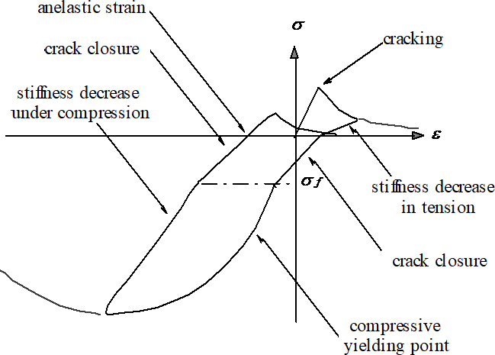

Figure 1 - Caption of a typical figure.

PREFERENCES, SYMBOLS AND UNITS
Consistency of style is very important. Note the spacing, punctuation and caps in all the examples below.
- References in the text: Figure 1, Figures 2-4, 6, 8a, b (not abbreviated)
- References between parentheses: (Fig. 1), (Figs 2-4, 6, 8a, b) (abbreviated)
- USA / UK / The Netherlands instead of U.S.A. / U.K. / Netherlands / the Netherlands
- Author & Author (1989) instead of Author and Author (1989)
- (Author 1989a, b, Author & Author 1987) instead of (Author, 1989a,b; Author and Author, 1987)
- (Author et al. 1989) instead of (Author, Author & Author 1989)
- Use the following style: (Author, in press); (Author, in prep.); (Author, unpubl.); (Author, pers. comm.)
Always use the official SI notations:
- kg / m / kJ / cm instead of kg. (Kg) / m. / kJ. (KJ) / cm.;
- 20°16′32′′SW instead of 20° 16′ 32′′ SW
- 0.50 instead of 0,50 (used in French text); 9000 instead of 9,000 but if more than 10,000: 10,000 instead of 10000
- 14C instead of C¹⁴ / C-14 and BP / BC / AD instead of B.P. / B.C. / A.D.
- 20 instead of ×20 / X20 / x 20; 4 + 5 > 7 instead of 4+5>7 but –8 / +8 instead of – 8 / + 8
- e.g. / i.e. instead of e.g., / i.e.

SUBMISSION OF MATERIAL
The camera-ready copy PDF file of the complete paper should be created and uploaded. All fig- ures should be included as high resolution images in the PDF file. Check whether the paper looks the same as in the Word file: Title at top of first page in 18 points, authors in 14 points and all other text in 11 points on 12 points line space, except for the small text (10 point on 11 point line space) used in tables, captions and references. Also check if the type width is 187 mm (7.36"), the page length is 272 mm (10.71") and that the space above the ABSTRACT is exactly as in this sample. Check that the number of pages does not exceed 10 when converted to PDF.

